Order of get / select request

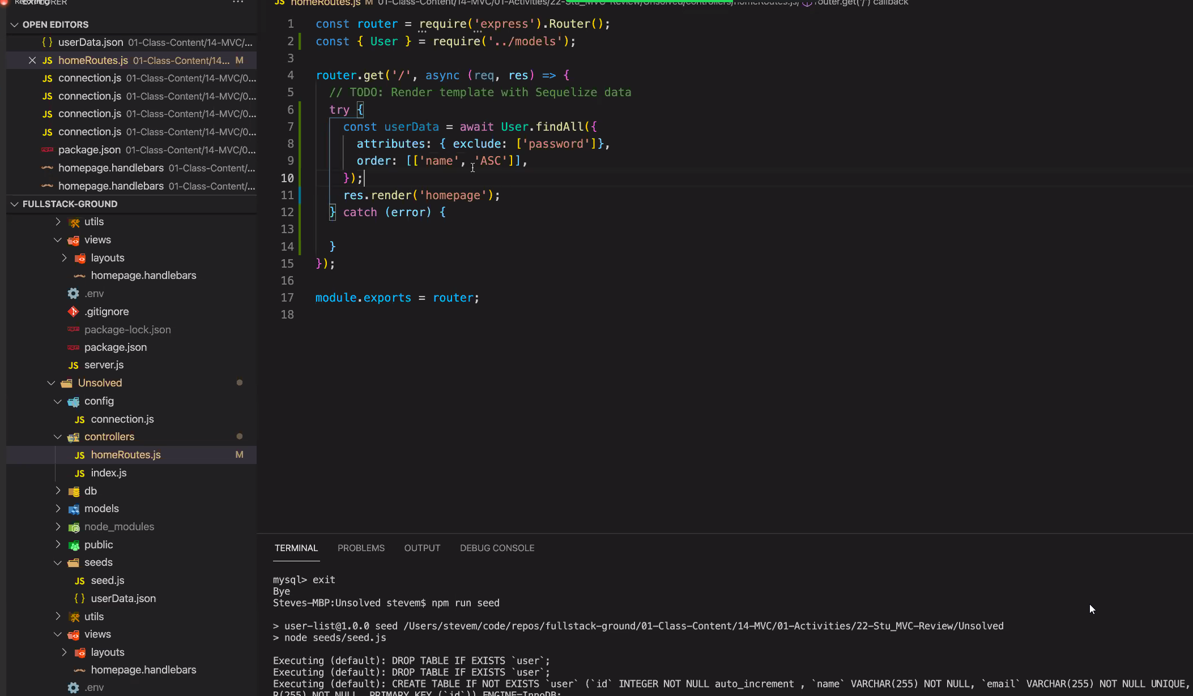

Authorization – add to project

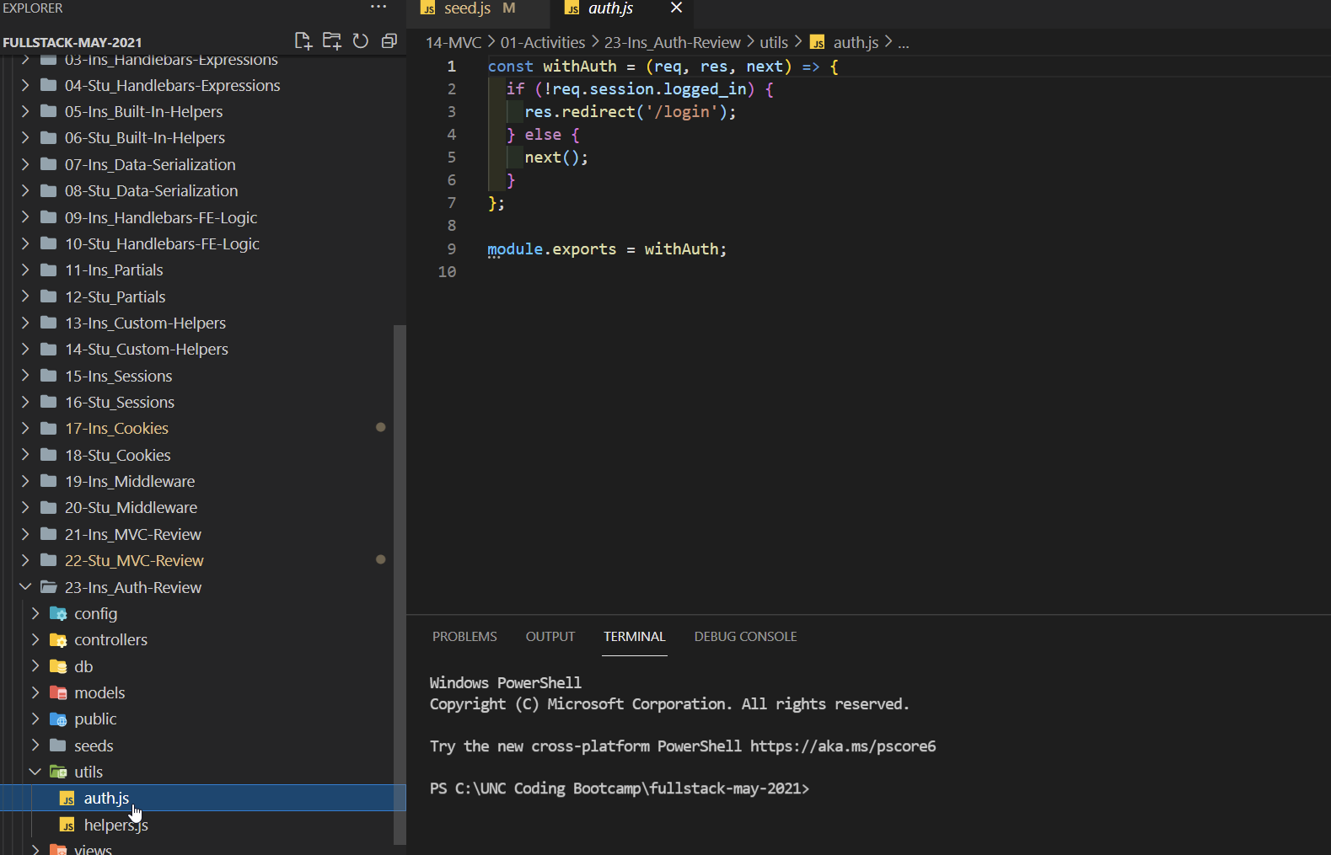

Being used in controllers

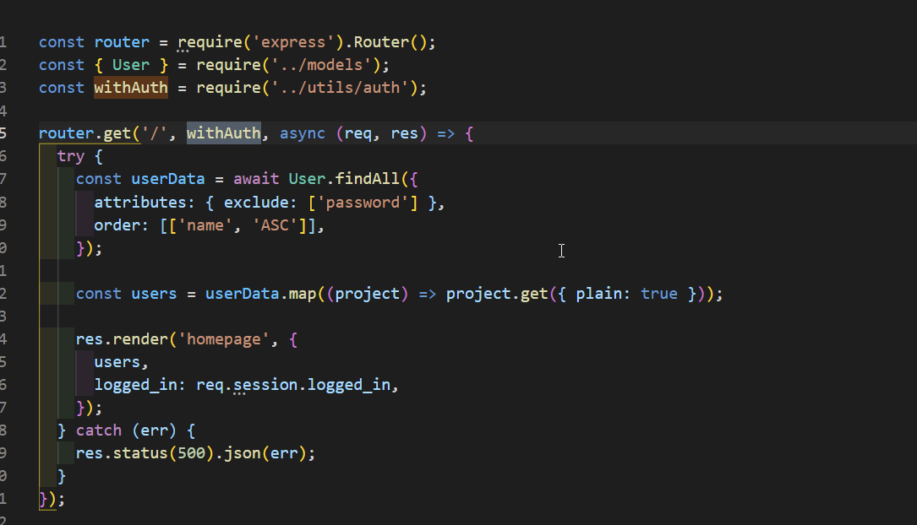

Runs each function in order, notice next() so it will run and redirect if needed else go to next

* YT vid for understanding cookies and sessions especially related to express if possible

-what is the purpose of ESLint? To check with issues in the code

Add as project dev dependency

  "devDependencies": {

    "eslint": "^7.12.1"

  }

.eslintrc.json, uses parameters for options, root:true prevents looking at parent directories also need to add support for es6. Maybe just copy file from activity 25

^implement on the HW along with the w2 nu checker.